- Complete the table below.
 | How many different definitions of this word are there in english? | What was the default Spanish meaning selected by Google translate? | How many different Spanish words are there for this one English word?
Leave

Play
Run
Type
Letter
Date

- Translate this sentence into French. Do not make any changes.

English: | I am ready for this weekend.
French:

- Translate this sentence one word at a time into French. Do not make any changes.

English: | I | am | ready | for | this | weekend.
French:

- Is there a difference in the results you received from 2 and 3? Why do you think this happened?

- Enter the result from 3 one word at a time, as shown below.
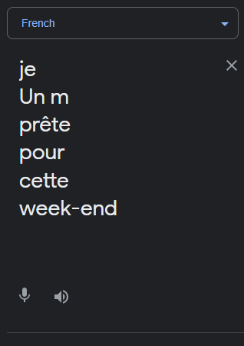
  - What is the result?

- Translate your result from 3 back into English. What was the result?

Original Phrase: | I am ready for this weekend
Translated 2x sentence:

- What changed?

- Why do you think this happened?

- Repeat this process with a language and sentence of your own choice.

- Translate this sentence one word at a time into French. Do not make any changes.
English:
??????:

- Translate your result back into english. What was the result?

Original Sentence:
Translated 2x Sentence:

- What changed?

